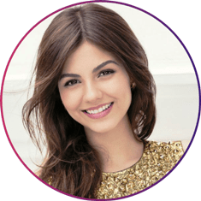****

Morbi a ante posuere, porta nibh at, interdum diam. Nullam condimentum velit enim.

Replace this sentence with your Expectations. To replace any tip text with your own, just select a line of text and start typing. For best results when selecting text to copy or replace, don’t include space to the right of the characters in your selection.

Father’s Name : Anupam Mishra

Father’s Occupation : Banker

Mother’s Name : Sunita Mishra

Mother’s Occupation : Banker

Family Type : Joint

Family Status : Middle Class

Siblings : 2

Younger/Elder Brother : 1

Younger/Elder Sister : 1

Paternal Aunt/Uncle : 2

Maternal Aunt/Uncle : 3

Gotra : -

**EXPECTATIONS**

I am a Caring trust worthy and warm person. I share a great bond with my family and have a big circle of friends. I totally believe in the old saying- A sound mind in a sound body and consider myself to be fit and energetic. I currently run our family business that employs over 70 people. We have one of the largest textile showrooms in the Dehradun. I have been instrumental in growing our family business and branching out into ecommerce. I have a Bachelor’s degree in business and look up to business visionaries such as Elon Musk. I am a teetotaler not smoke.

**ABOUT ME**

**YOUR NAME**

**MY SKILLS**

**FAMILY DETAILS**

Andy123@email.com

www.rockson123.com

**HOBBIES**

**EDUCATION**

Reading

**BSc in multimedia in design** (2006)

XYZ University

Morbi a ante posuere, porta nibh at, interdum diam. Nullam condimentum velit enim, id molestie enim scelerisque auctor

**Master in user experience design** (2012)

ABC University

Basketball

Music

Hiking

Italian

German

Spanish

English

**LANGUAGES**

+123 456 789