Ella Mitchell
Interior Designer


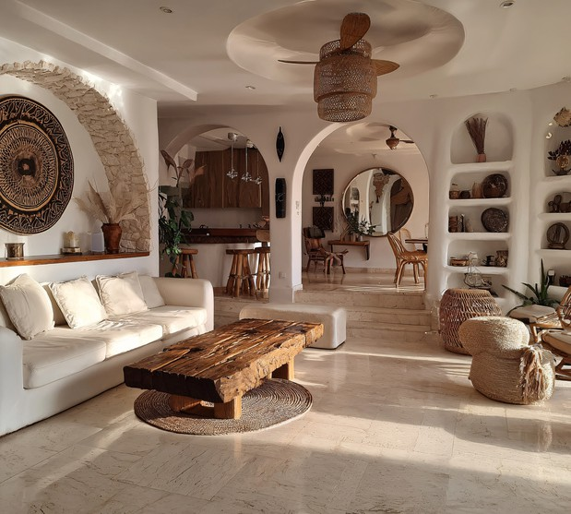

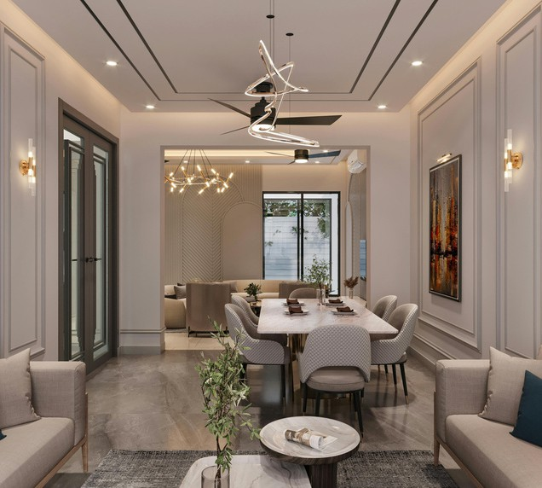

CONTACT
Phone: 777777777777
Email: @TechGuruPlus.com Address :New York City Portfolio: TechGuruPlus.com

EDUCATION
Bachelor of Interior Design – Universitas Rimberio
2016 – 2020

SKILLS
AutoCAD, SketchUp, Enscape, 3ds Max, V-Ray Adobe Photoshop & Illustrator
Space Planning & Concept Development
FF&E Knowledge, Budgeting

AWARDS & CERTIFICATIONS
Certified Interior Design Professional (CIDP), 2021 Best Residential Project Award – Campus Interior Expo 2019

LANGUAGES
Bahasa Indonesia (Native) English (Professional Proficiency)

PROFESSIONAL SUMMARY
Creative and detail-oriented Interior Designer with 3+ years of experience in residential and commercial design.

WORK EXPERIENCE
Interior Designer – Paucek & Lage
2022 – Present
Develop residential design concepts and layouts based on client needs Create 3D renderings and mood boards for presentations Collaborate with contractors and suppliers throughout project execution
Junior Designer – Interior Art & Co
2020 – 2022
Assisted senior designers in creating detailed drawings (AutoCAD & SketchUp)
Conducted site visits and reported progress
Handled sample selections (finishes, furniture, lighting)

PORTFOLIO

