Noah Parker
Professional Digital Marketer

About Me
Results-driven digital marketer with a strong background in developing creative campaigns and optimizing online presence. Experienced in handling social media platforms, analyzing performance metrics, and executing targeted strategies to boost brand awareness. Known for being proactive, adaptable, and focused on delivering measurable results.







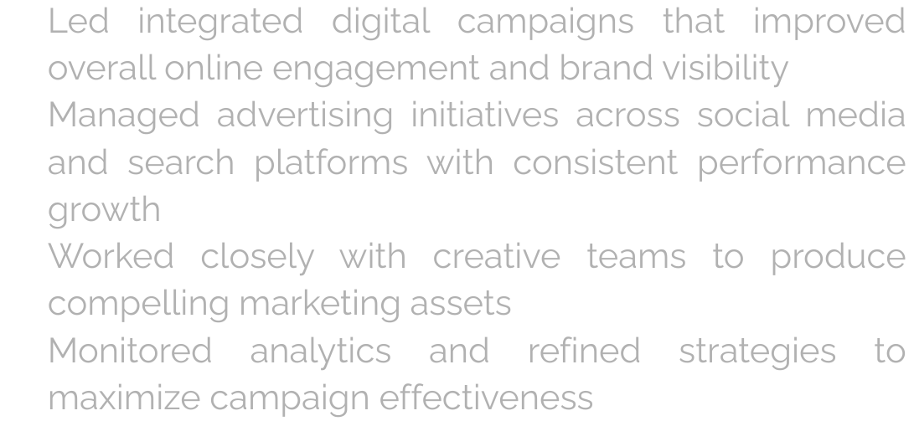
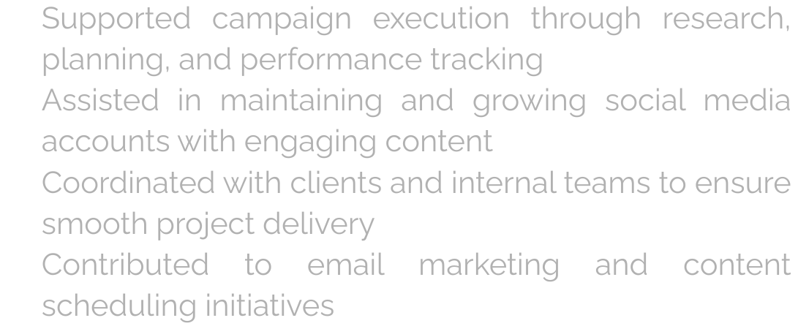
Education
Bachelor of Business – Marketing Salford & Co. University
2018 – 2022
Salford & Co. University 2015 – 2017

Contact
7777777777

@TechGuruPlus www.TechGuruPlus.com hello@TechGuruPlus.com New York City

Skill
Digital Campaign Management Content Development Marketing Analytics
Social Media Strategy Team Collaboration Presentation Skills

Experience
Digital Marketing Specialist Salford & Co. | Jan 2023 – Present

Led integrated digital campaigns that improved overall online engagement and brand visibility Managed advertising initiatives across social media and search platforms with consistent performance growth
Worked closely with creative teams to produce compelling marketing assets
Monitored analytics and refined strategies to maximize campaign effectiveness

Digital Marketing Associate Salford & Co. | Jan 2021 – Dec 2022

Supported campaign execution through research, planning, and performance tracking
Assisted in maintaining and growing social media accounts with engaging content
Coordinated with clients and internal teams to ensure smooth project delivery
Contributed to email marketing and content scheduling initiatives

English French Spanish

